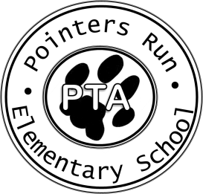
Pointers Run Elementary School PTA
Disbursement Request
2023/2024 School Year

Amount Requested: $ _____________________ Date Requested: / /_____
(Please attach invoice to be paid or original receipts to be reimbursed)

Pay to the Order of:_______________________________________________________________

Address (to mail if needed): ________________________________________________________________________________

Charge to the Account of:
PTA Committee:_________________________________________________________
OR
Position/Grade/FT/PT:____________________________________________________
(for teacher/staff reimbursement only)

Purpose:________________________________________________________________________

Itemized Expenses:
Description | Amount
TOTAL $

Requested by: (print name) ____________________________ Phone Number: _______________

Signature: ____________________________________E-mail: ______________________________

****************************************************************************************
PTA Use Only:

Paid by Check Number: _________ Date: ________________ By: __________________________

Issuing Officer’s Signature: ____________________________ Title: ________________________

